P.O. Box 419
Hollidaysburg, PA 16648

124 South Richard Street
Bedford, PA 15522

Press Release
Contact: Marty Malone  Phone 814.695.7500  Fax 814.695.7505  MMalone@LehmanEngineers.com  www.LehmanEngineers.com | FOR IMMEDIATE RELEASE  September 8, 2022

LEHMAN ENGINEERS HORSE TRAIL RIDE AND TRAIL WALK TO BENEFIT DREAMS GO ON

Hollidaysburg, Pennsylvania - On Sunday, October 2, 2022, the 16th Annual Lehman Engineers Horse Trail Ride and Trail Walk to benefit Dreams Go On, a non-profit therapeutic horseback riding organization, will take place at Canoe Creek State Park. This unique event brings horse back riders and trail walking enthusiasts together for a great cause. Dreams Go On provides therapeutic horseback riding sessions to children and young adults in Blair County, PA.

The public is invited to register to participate in the event. All horse trail riders and trail walkers are encouraged to register online at www.DreamsGoOn.com and collect pledges to donate to Dreams Go On. They may also register by mailing the online event brochure registration page to: Dreams Go On Trail Ride/Walk, 311 Heather Avenue, Altoona, PA 16602. Brochures also available at Canoe Creek State Park, Lehman Engineers and area businesses. Corporate, organizations, and family teams are encouraged. The top fundraising team will receive a pizza party at Best Way Pizza in Duncansville, gift cards from Hoss’s Steak and Sea House / Marzoni’s, and DelGrosso’s Park and Laguna Splash All-Day passes. The top three fundraising individuals will receive a Hoss’s / Marzoni’s gift card (1st Place: $50, 2nd Place: $30, and 3rd Place: $20), a DelGrosso’s Park and Laguna Splash All-Day Pass, and a large square pie from Best Way Pizza. Registration is $15 and all registered participants will get a free event t-shirt. Registered walkers and horseback riders will also get a free BBQ Chicken lunch provided courtesy of Imler’s Poultry and Hoss’s Steak and Sea House.

Late registrations will be accepted the day of the event. The event is on rain or shine. Horseback riders must provide their own horses. Registration and check-in on the day of the event is from 9:00 a.m. to 9:45 a.m. for horse trail riders and trail walkers. The Horse Trail Ride and Walk both begin at the same time and will depart at 10:00 a.m. For the Horse Trail Ride, the Bridle Trail loops around the park and will be between a 2 to 2.5-hour trail ride. Two choices for the Trail Walk are available. Registrants may choose the Limestone Trail (1.2 miles) near the kilns with a view of a scenic stream, or Lakeview, which is a .5-mile handicap accessible loop (1/4 portion of the loop is crushed limestone) that can be repeated for 1 to 5 miles while enjoying the beautiful view of Canoe Lake. Karen Kurtz, lead therapeutic horseback riding instructor at Dreams Go On, will guide horseback riders. Trail walkers are invited to walk the trail as a group, following celebrity emcee, Joe Murgo, WTAJ Chief Meteorologist.

The 2022 Dreams Go On Goodwill Ambassador is Elliott Sheetz. Elliott is an 11-year-old who loves to learn and ride horses. Dreams Go On has been a part of Elliott’s life for over six years and he continues to challenge himself by riding different horses. Elliott’s favorite game is ‘leapfrog’ on horseback. His goal is to ride on a more independent basis. Elliott is the son of Ryan and Julie Sheetz.

A special craft area for kids will be available for young participants and Dreams Go On riders and their families. All are encouraged to bring a picnic blanket and enjoy Canoe Creek State Park after the walk and ride ends.

Other activities registrants may participate in include a silent auction and varied amenities at the state park. The raffle will feature gift cards, baskets, and great gifts from area businesses and Dreams Go On supporters. Businesses and organizations can still support the event with a sponsorship or by donating an item, basket, or gift card. Interested parties should contact event chairperson, Betsy Lehman at 814-695-7500 or BLehman@Lehmanengineers.com.

Commenting about the event for Dreams Go On, Deb Kelly, Program Manager, stated, “I look forward to this year’s Lehman Engineers Horse Trail Ride & Trail Walk at Canoe Creek. We hope people interested in supporting Dreams Go On will come out and join us at our largest annual fundraising event. Over the past 15 years, nearly $300,000 has been raised from this event from Dreams Go On. It’s a great day of fun and we thank our friends at Lehman Engineers for their continued support to help us plan a fun filled day!” Event brochures can be found at DreamsGoON.com, and the offices of P. Joseph Lehman, Inc., Consulting Engineers, Canoe Creek State Park, and many area businesses.

This event is made possible thanks to the planning committee, volunteers, and servant leaders from Saint Francis University Phi Lambda Psi sorority and the PSU Sheetz Fellows. Volunteers are also needed at the therapeutic horseback rides that take place at the Dreams GO On facility located on Turkey Valley Road, Hollidaysburg, PA. Please contact Deb Kelly at dkelly1006@atlanticbb.net to learn how to become a therapeutic horseback riding volunteer and visit www.DreamsGoOn.com for more information.

PRESS PHOTO ATTACHED:

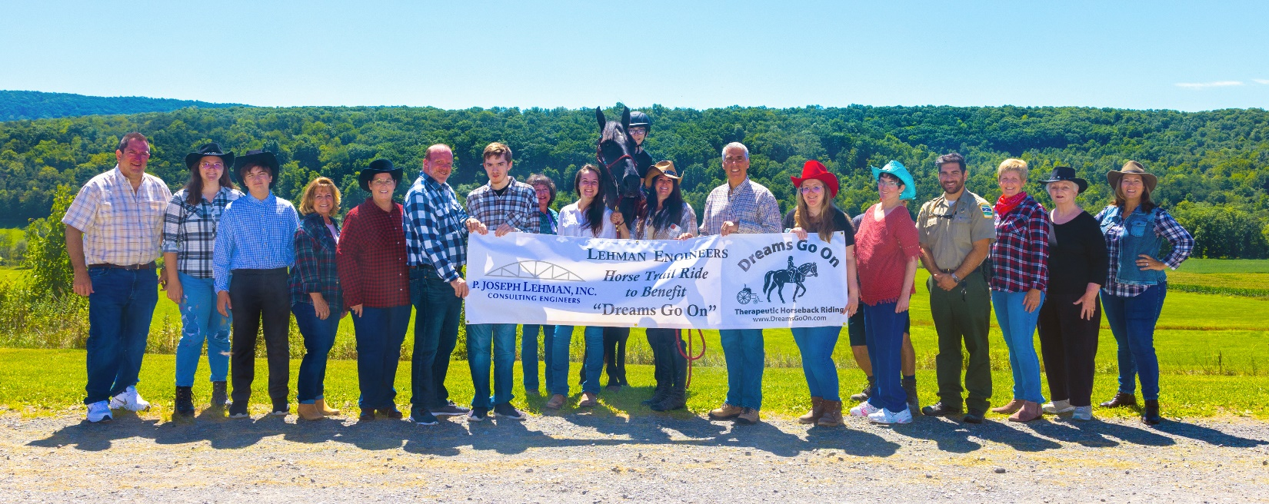

Preparing for the 2022 Lehman Engineers Horse Trail Ride and Trail Walk to Benefit Dreams Go On are: (from left) From Lehman Engineers: Joe Lehman, Jr., P.E., President; Lauren Lehman, Junior Committee Member; Joey Lehman, Volunteer; Tammie Fleck, Office Manager; Denise Lear, Controller; and Jim Frank, Client Services Director; Carson Frank, Independent DGO Rider, Deb Kelly, DGO Program Manager; Sarah Stanley, DGO Assistant Instructor; Elliott Sheetz, 2022 Dreams Go On Goodwill Ambassador on “Black Jack”; Melinda Anderson, DGO Assistant Therapeutic Riding Instructor & Board Member; Joe Murgo, WTAJ Chief Meteorologist; Kristin Murgo, DGO Assistant Instructor; Sue Lehman, DGO Founder; Joe Basil, Canoe Creek State Park Ranger; Brenda Fix, DGO Treasurer & Board Member; Annette Lehman, Board Member; and Betsy Lehman, Lehman Engineers Horse Trail Ride & Trail Walk Committee Chair.

